**ACTIVITY 3**

Open index.html on **Chrome**

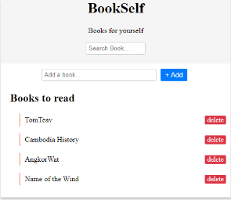

Open the “**Console**” tab of the developer’s tools (Ctrl + shift + I)

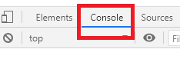

**Q1** - Execute each of the following command, try to understand what it does, and explain in the table below.

var newH2= document.**createElement**("h2")

newH2.textContent = ‘hello there !’

document.getElementById("wrapper").**appendChild**(newH2)

|  |  |
| --- | --- |
| **INSTRUCTION** | **YOUR DEFINITION** |
| document.**createElement**(name) | It will create element h2 |
| element.**appendChild**(child) | It will appendChild h2 |

**Q2** – Try to **apply these instructions** to create new elements (anything you want)

* **Using the Chrome debug tools** to understand what is happening.